ARP Table

🌐 What Is an ARP Table?
# Source: Chatgpt (GPT‑5 Mini) at [12/14/2025]
An ARP Table (Address Resolution Protocol Table) is a lookup table that stores IP-to-MAC address mappings on a local network. It's used to help devices communicate with each other over Ethernet or Wi-Fi by resolving IP addresses to physical MAC addresses.

🧠 Simple Definition:
# Source: Chatgpt (GPT‑5 Mini) at [12/14/2025]
The ARP Table keeps track of which MAC address is associated with which IP address on a local network.

🔍 Why ARP Is Needed
# Source: Chatgpt (GPT‑5 Mini) at [12/14/2025]
On a LAN:
- Devices communicate using MAC addresses (Layer 2).
- Applications and IP routing use IP addresses (Layer 3).
- So ARP is needed to translate IP → MAC.

📦 Sample ARP Table
# Source: Chatgpt (GPT‑5 Mini) at [12/14/2025]
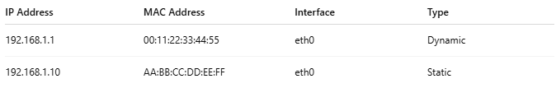
IP Address | MAC Address | Interface | Type
192.168.1.1 | 00:11:22:33:44:55 | eth0 | Dynamic
192.168.1.10 | AA:BB:CC:DD:EE:FF | eth0 | Static
🧠 MAC addresses are hardware-level identifiers of devices.

🔧 View ARP Table

▶ On Windows:
# Source: Chatgpt (GPT‑5 Mini) at [12/14/2025]

arp -a

▶ On Linux/macOS:
# Source: Chatgpt (GPT‑5 Mini) at [12/14/2025]

ip neigh

Or
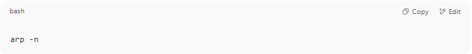
arp -n

🛠 Types of ARP Entries
# Source: Chatgpt (GPT‑5 Mini) at [12/14/2025]
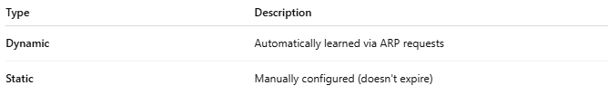
Type | Description
Dynamic | Automatically learned via ARP requests
Static | Manually configured (doesn't expire)

🔁 How It Works (Simplified)
# Source: Chatgpt (GPT‑5 Mini) at [12/14/2025]
- Device A wants to send a packet to 192.168.1.5.
- It checks its ARP table — no entry found.
- Sends an ARP Request: "Who has 192.168.1.5?"
- Device B responds with its MAC: "I do! My MAC is aa:bb:cc:dd:ee:ff."
- Device A adds this to its ARP table and sends the packet.

✅ Summary
# Source: Chatgpt (GPT‑5 Mini) at [12/14/2025]
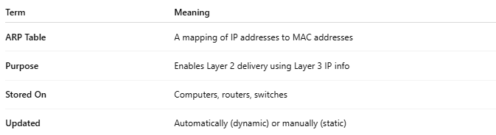
Term | Meaning
ARP Table | A mapping of IP addresses to MAC addresses
Purpose | Enables Layer 2 delivery using Layer 3 IP info
Stored On | Computers, routers, switches
Updated | Automatically (dynamic) or manually (static)

